5.Write a program to create the following methods for the class “FlightManagement”
a. detailsOfFlight (no return type)
b. displayDetails with return type "String"
Return string values as "boardingno+flightname+amount+ticktno"
c. initialize variable with below values:
ticktno=100
boardingno=88667
flightname="Indigo";
amount=80000;
NOTE: Use public access modifiers for the above methods and variables
public class FlightManagement {
public int ticktno=100;
public int boardingno=88667;
public String flightname="Indigo";
public int amount=80000;
public void detailsOfFlight()
{
}
public String displayDetails()
{
return (boardingno+flightname+amount+ticktno);
}
}

6.
Write a program to create the following methods for the class “TrainManagement”
a. getTrainDetails
b. displayTrainDetails with return type String
(return trainname)
c. initialize variable with below values:
Pnrno=4562342;
Trainno=8098;
trainname="TVCExpress";
Fare=679;
NOTE: Use private access modifiers for the above methods and variables

public class TrainManagement {
private int Pnrno=4562342;
private int Trainno=8098;
private String trainname="TVCExpress";
private int Fare=679;
private void getTrainDetails()
{
}
private String displayTrainDetails()
{
return(trainname);
}
}

7.public class Fieldcode {
public int x=23;
protected String companyname="DSRC";
private int y=-4;
String deleteEmployee()
{
return companyname;
}
int sum()
{
return x+y;
}
}

8.Write a Program to create following methods
a. Create a class named Emp.
b. Create a public method named “addEmp” with no arguments and print any data
c. Create a public method named Employee with 2 arguments of type String and int. Assign any value to each and return integer value
d. Create a private method named number with 1 argument of type int.Assign any value to it and return integer value

public class Emp {
public void addEmp(){
System.out.println("java");
}
public int Employee(String name, int num)
{
name="hari";
num=10;
return num;
}
private int number(int num1){
num1=10;
return num1;
}
}

9.
Write a Java program to create a default constructor for the class ”FlightManagement” and assign the values for the class members
a. Values are :
i. ticktno=100
ii. boardingno=88667
iii. flightname="Indigo"
iv. amount=80000

public class FlightManagement {
int ticktno = 100;
int boardingno =88667;
String flightname = "Indigo";
int amount = 80000 ;

public static void main(String[]args){
FlightManagement ob=new FlightManagement();
System.out.println(ob.amount);
}}
10.
Write a Java program to create a Parameterized constructor for class “FlightManagement” and assign the values to below fields
i. ticktno=100
ii. boardingno=88667
iii. flightname="Indigo"
iv. amount=80000
public class FlightManagement {
public int ticktno=100;
public int boardingno=88667;
public String flightname="Indigo";
public int amount =80000;
public FlightManagement(int ticktno, int boardingno, String flightname, int amount ){
this.ticktno=ticktno;
this.boardingno=boardingno;
this.flightname=flightname;
this.amount=amount;
}
}

11.Write a Java program to create a default constructor for the class “TrainManagement” and assign the values for the class members
a. Values are :
Pnrno=4562342
trainno=8098
trainname="TVCExpress"
fare=679

public class TrainManagement {
int Pnrno=4562342;
int trainno=8098;
String trainname="TVCExpress";
int fare=679;

public static void main(String[]args){
TrainManagement ob = new TrainManagement();
System.out.println(ob.fare);
}
}

12.public class TrainManagement {
int Pnrno=4562342;
int trainno=8098;
String trainname="TVCExpress";
int fare=679;
public TrainManagement(int Pnrno, int trainno, String trainname, int fare)
{
this.Pnrno=Pnrno;
this.trainno=trainno;
this.trainname=trainname;
this.fare=fare;
}
}

13.Write a program to create a class “ CarDetails” and create a constructor for the above class to assign the default values for the class members
Values are :
carID = 1;
carName = "Alto";
carType = "hatchback";
carPrice = 45000.00;
public class CarDetails {

public int carID=1;
public String carName="Alto";
public String carType="hatchback";
public double carPrice=45000.00;
public CarDetails(){
}
}

14.

public class CarDetails {
public int carID=1;
public String carName="Alto";
public String carType="hatchback";
public double carPrice=45000.00;
public CarDetails(int ID, String Name, String Type, double Price){
carID=ID;
carName=Name;
carType=Type;
carPrice=Price;
}
public CarDetails(){
}
}

15.
public class Cuboid {
/*
a)Create Default Constructor for class "Cuboid" and assign default value for
length=10;
breadth=10;
height=10;
b)CreateParameterized Constructor for class "Cuboid" and assign user supplied values
c)Declare method with name "getVolume" ,return type "int" and perform the logic to find volume of cuboid
d)create main method to call 2 constructor
*/
public int length=10;
public int breadth=10;
public int height=10;

public Cuboid(){
length=10;
breadth=10;
height=10;
}

public Cuboid(int l, int b , int h){
length=l;
breadth=b;
height=h;
}

public int getVolume(){
return (length*breadth*height);
}
public static void main(String[]args){
Cuboid ob=new Cuboid();
ob.getVolume();
}
}

16.
public class ClassA {
static int a=100;
static int b=10;
public static double data()
{
double c=Math.sqrt(a-b);
return c;
}
public double funcn()
{
return data();
}
}

17.

public class A {
static float a=100;
static float b=10;
static float c=102;
public static double data()
{
double d=Math.max(b, c);
double e=++a;
double sum=d+e;
return sum;
}
public double funcn()
{
return data();
}
}

18.
public class CarDetails {
public int carID=1;
public String carName="Alto";
final int carPrice=500000;
public String displayCarDetails()
{
return (carName+carPrice);
}
}

19.

public class Constants {
public final int a=10;
public int b=20;
public int printfinal()
{
b=30;
return a+b;
}
}

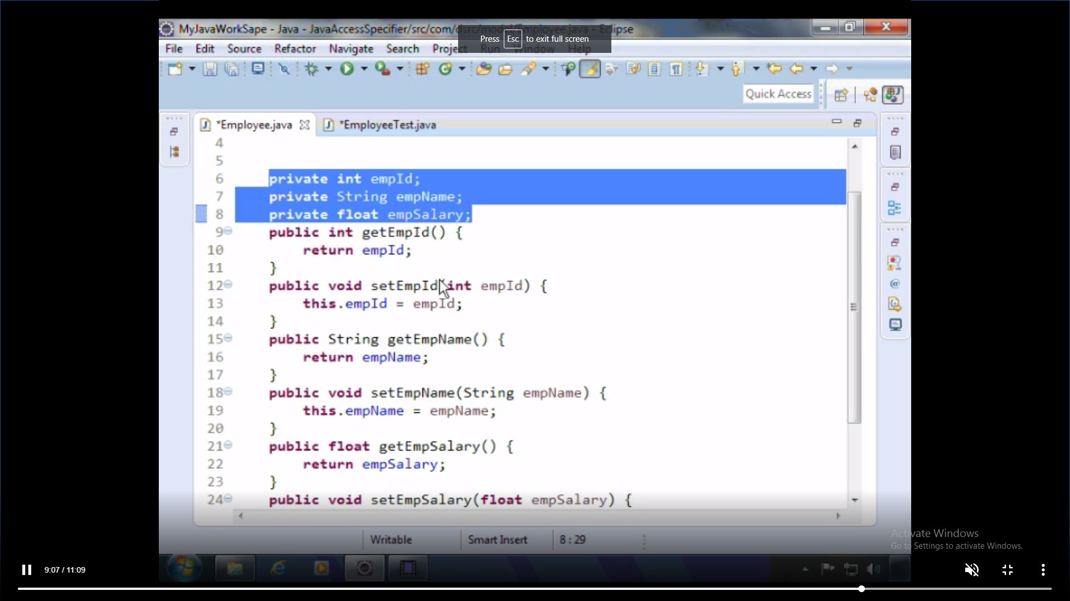
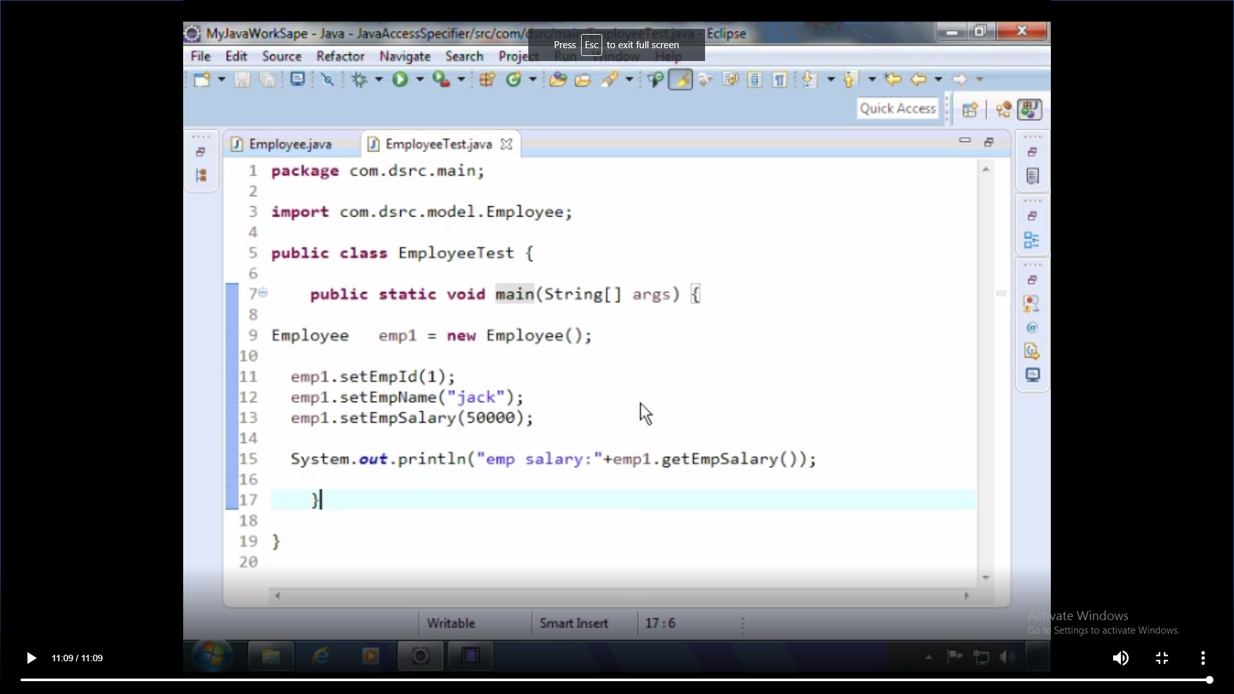

20.
public class Encaps {
private int Roll;
private int Age;
private String Name;
public int getRoll() {
return Roll;
}
public int setRoll(int roll) {
Roll = roll;
return Roll;
}
public int getAge() {
return Age;
}
public int setAge(int age) {
Age = age;
return Age;
}
public String getName() {
return Name;
}
public String setName(String name) {
Name = name;
return Name;
}

}
class Mainmethod
{
public static void main(String[] args){
Encaps ob=new Encaps();
ob.setAge(10);
ob.setRoll(12);
ob.setName("hari");
ob.getAge();
ob.getRoll();
ob.getName();
}

}

